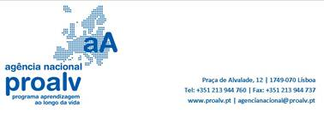

Dear Sir,

TecMinho was involved in a Tempus project with Uzbekistan in the past and is involved in 2 partnerships for the 2103 call.

Unfortunately TecMinho cannot be a project promoter (we are not a University) so we can only apply for tempus as project partners. We want to apply for the max. number of Tempus partnership projects.

So if you are applying for a TEMPUS project (as the coordinator or a partner) and you need a Portuguese partner please get in contact or forward my contact to the project responsible. Our institutional and personal cvs are attached.

Thank you very much in advance,
Kind regards,
Ana

Ana Dias
anadias@tecminho.uminho.pt
Centro e-learning
TecMinho/Gabinete De Formação Contínua
Universidade do Minho
Campus de Azurém
4800-048 Guimarães
www.tecminho.uminho.pt
t +351 253 510 590
m +351 91 457 94 40

